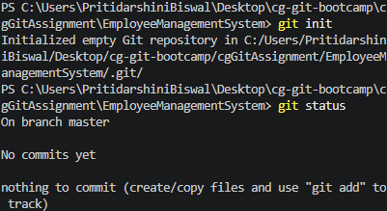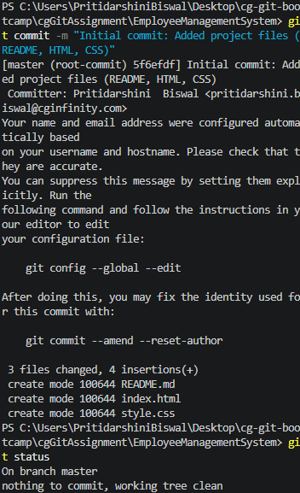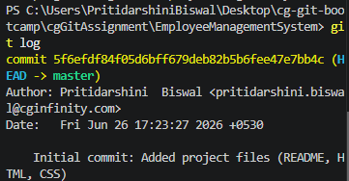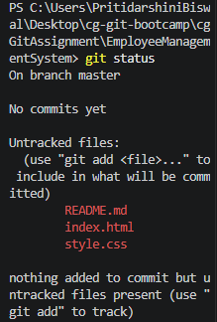
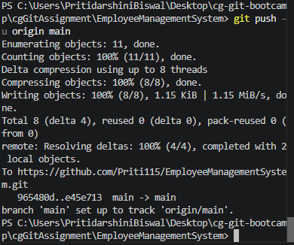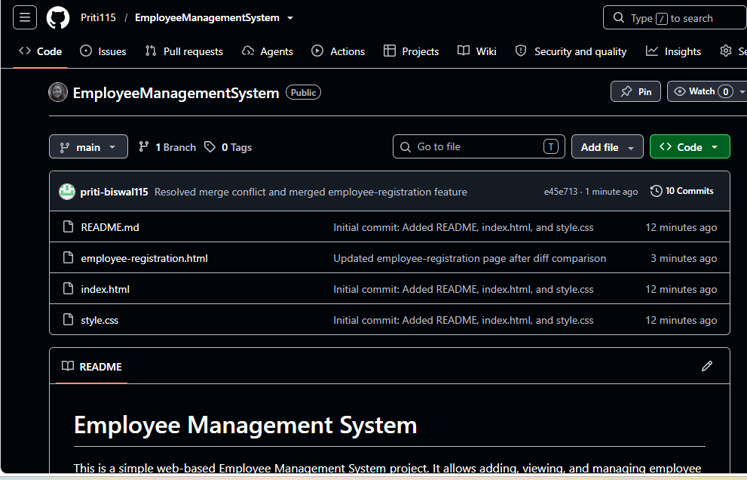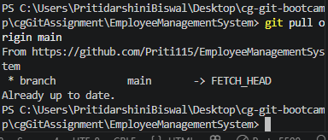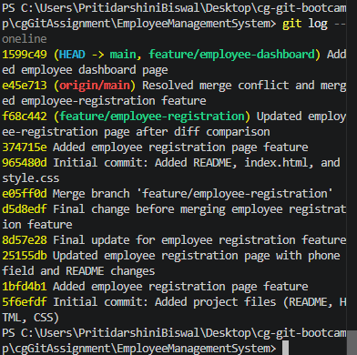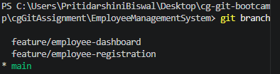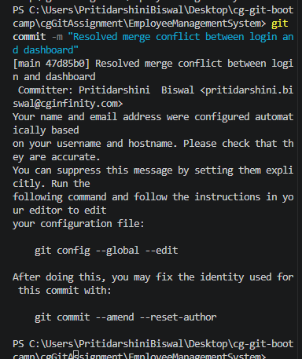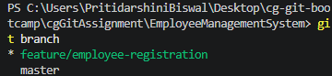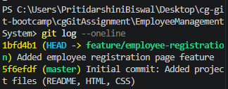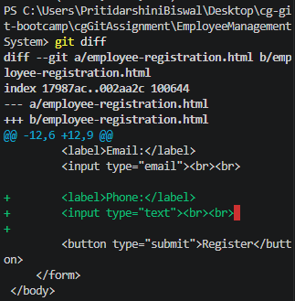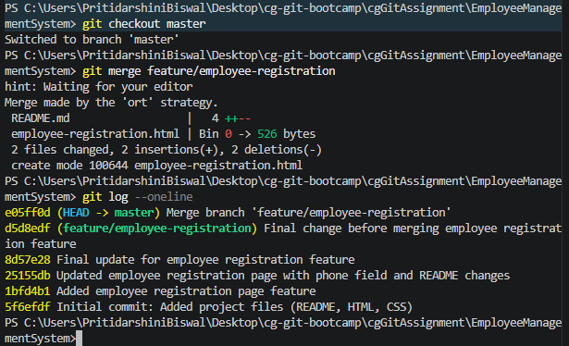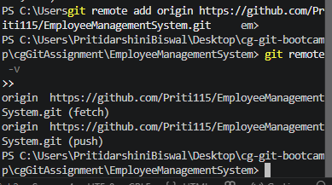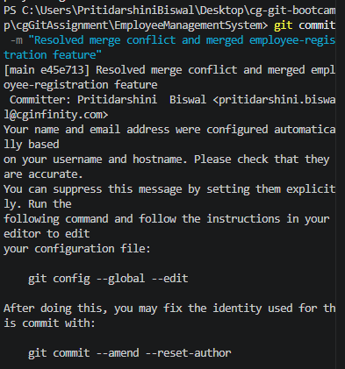

PS C:\Users\PritidarshiniBiswal\Desktop\cg-git-bootcamp\cgGitAssignment\EmployeeManagementSystem> git log --oneline
cb39bd7 (HEAD -> main, origin/main) Fixed unresolved merge conflict in README
c8569e7 Added branching strategy for Task 17
47d85b0 Resolved merge conflict between login and dashboard
8c9e8d9 (origin/feature/dashboard-conflict, feature/dashboard-conflict) Added dashboard conflicting changes
1ab7e73 (origin/feature/login, feature/login) Added login feature changes
1599c49 (origin/feature/employee-dashboard, feature/employee-dashboard) Added employee dashboard page
e45e713 Resolved merge conflict and merged employee-registration feature
f68c442 (origin/feature/employee-registration, feature/employee-registration) Updated employee-registration page after diff comparison
374715e Added employee registration page feature
965480d Initial commit: Added README, index.html, and style.css
e05ff0d Merge branch 'feature/employee-registration'
d5d8edf Final change before merging employee registration feature
8d57e28 Final update for employee registration feature
25155db Updated employee registration page with phone field and README changes
1bfd4b1 Added employee registration page feature
5f6efdf Initial commit: Added project files (README, HTML, CSS)
PS C:\Users\PritidarshiniBiswal\Desktop\cg-git-bootcamp\cgGitAssignment\EmployeeManagementSystem>

